Santa Clara University

15
OOAD Assignment 3

My Expense Tracker
ANUSHA GOVINDAN-W1167283

Description of the Code:
The primary classes used for this project are as follows

ExpenseTracker.java
The entrance class which has the main method

ExpenseController.java
It is the controller class which defines the UI of the controller Expense Controller contains the GUI for controls and panel for views. The control in turn has 2 control panels:
- Current Expense Panel : Current Expense has controls for setting the limit and adding today's expenses
- Expense History Panel: This panel has controls to access the expense history between a start date and end date and by category.
- It also has methods defined to add table and chart views in the pnlViews panel

ExpenseModel.java
This class hosts the methods for the logic and database updates. The important methods are getExpenseDetails() and getInitialVal().
- getExpenseDetails() will reset the parameters to their current values as per the database
- getInitialVal() will get the cumulative values and load the hashmap with limit specific expenses.
Hence get getExpenseDetails() and getInitialVal() are called extensively by other methods in that class to load and update the parameter which is to be used by other views classes.

ExpenseTableView.java
Defines the UI for the textual view providing 2 details:
Current Expense Status: Always displays the current status
Table View of Selected Data: Always displays the status of the selected data

ExpenseVisView.java
This class displays the current status of the expenses whether the limit is set or not. It does not reflect any data related to expense history

Screenshots
- Enter an amount, the expense limit, either per day or for a period of time (a week or a month). You must provide options to set either by day, or by month or from a specific date to a specific date. A button to save the amount for the expense limit and duration.
The opening screen set is given below: The screen has
- 2 control panels-Current Expense Tracker and Expense History Panel
- 2 views Panel-Table view and Chart View

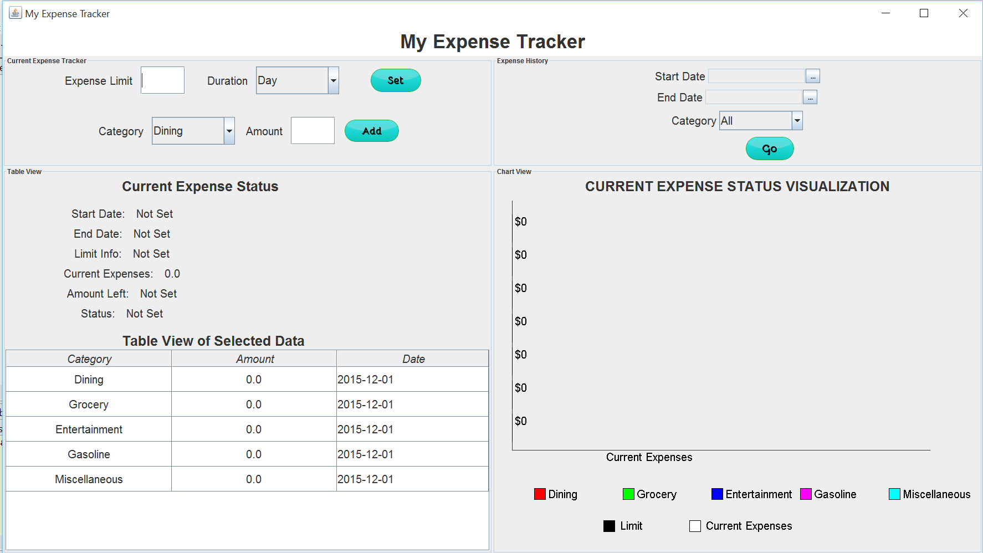
The user can set the limit for a day, week or a month and click on set. For example here the expenses are set as 2000 for a week and set button is clicked.
- Now the limit is set and is displayed both visually as well as in the table view along with the start and end date.
- Current Expenses is the amount spent till now and “Amount Left” is the amount that can be spent within the limit.i.e (Amount Left=Limit-Current Expenses).
- If the limit is not set the Current expenses displays today’s expenses.. The display after the limit set is displayed below
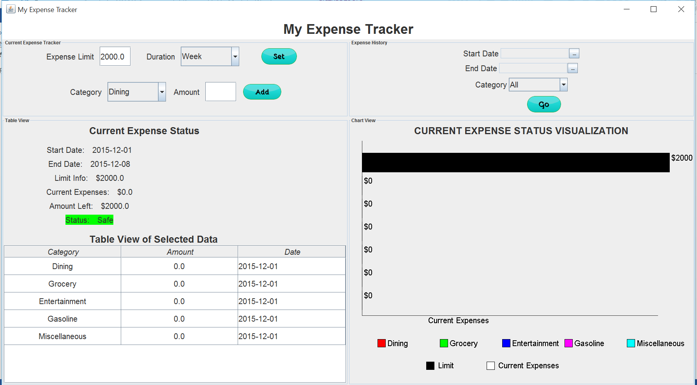
- Provide categories of expenses (eg: food, eating out, clothes, entertainment, gas etc).
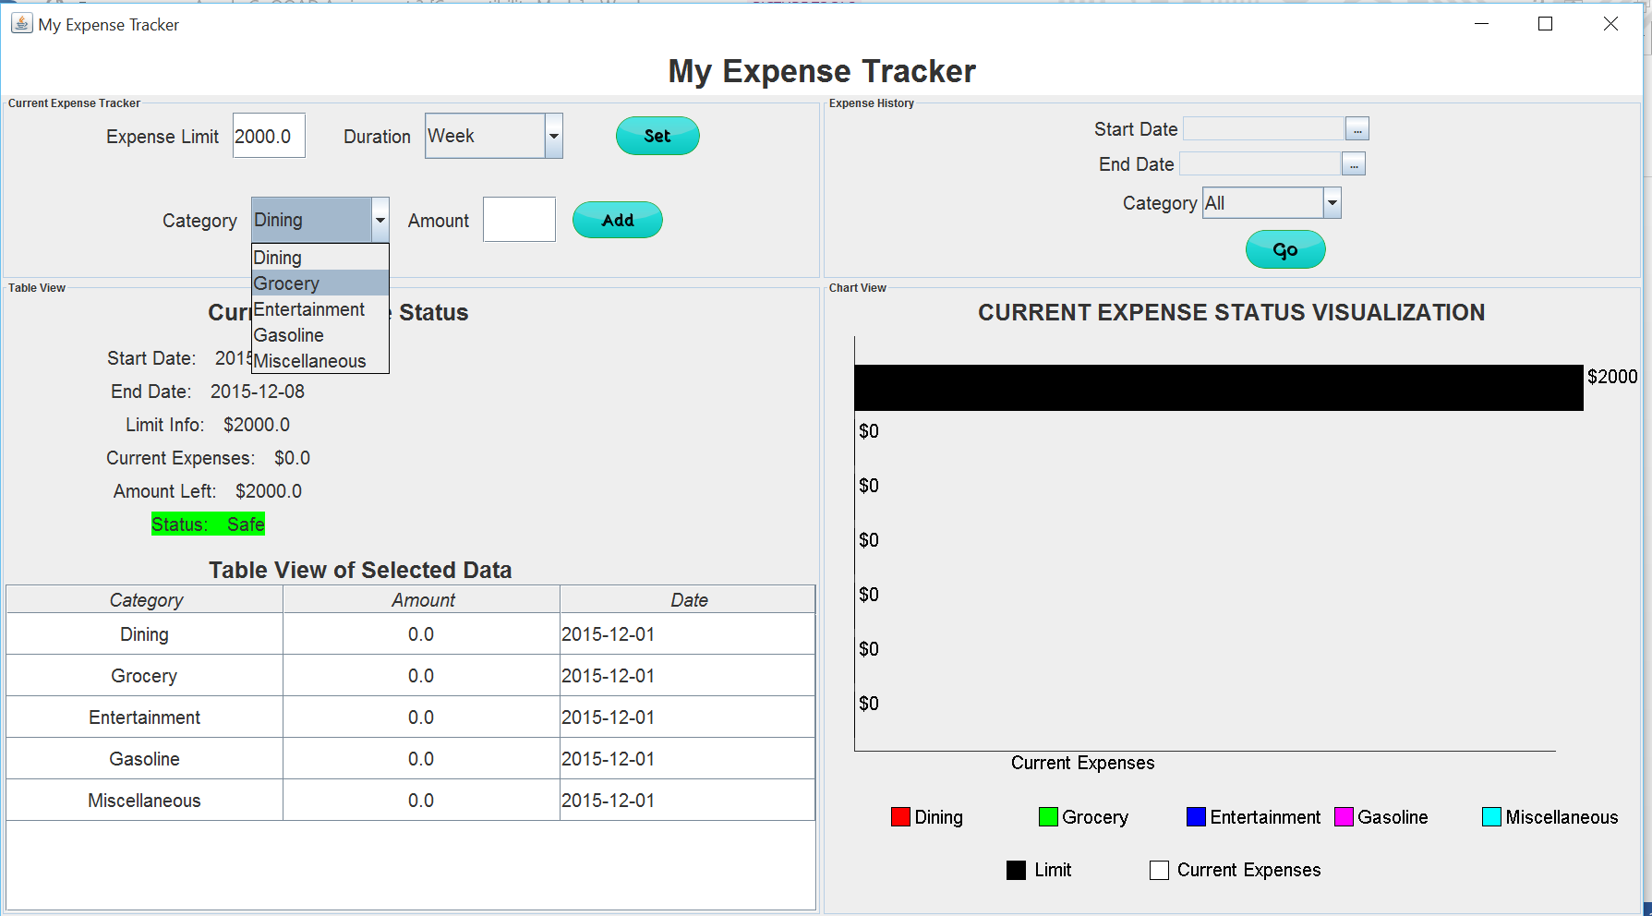
Provided Categories are Dining, Grocery, Entertainment, Gasoline, Miscellaneous.
- Enter an amount spent under the selected category. If the amount entered results in the total expenses thus far to exceed the expense limit (set for the day, for the example), shows an alert that expense limit is exceeded by the amount.
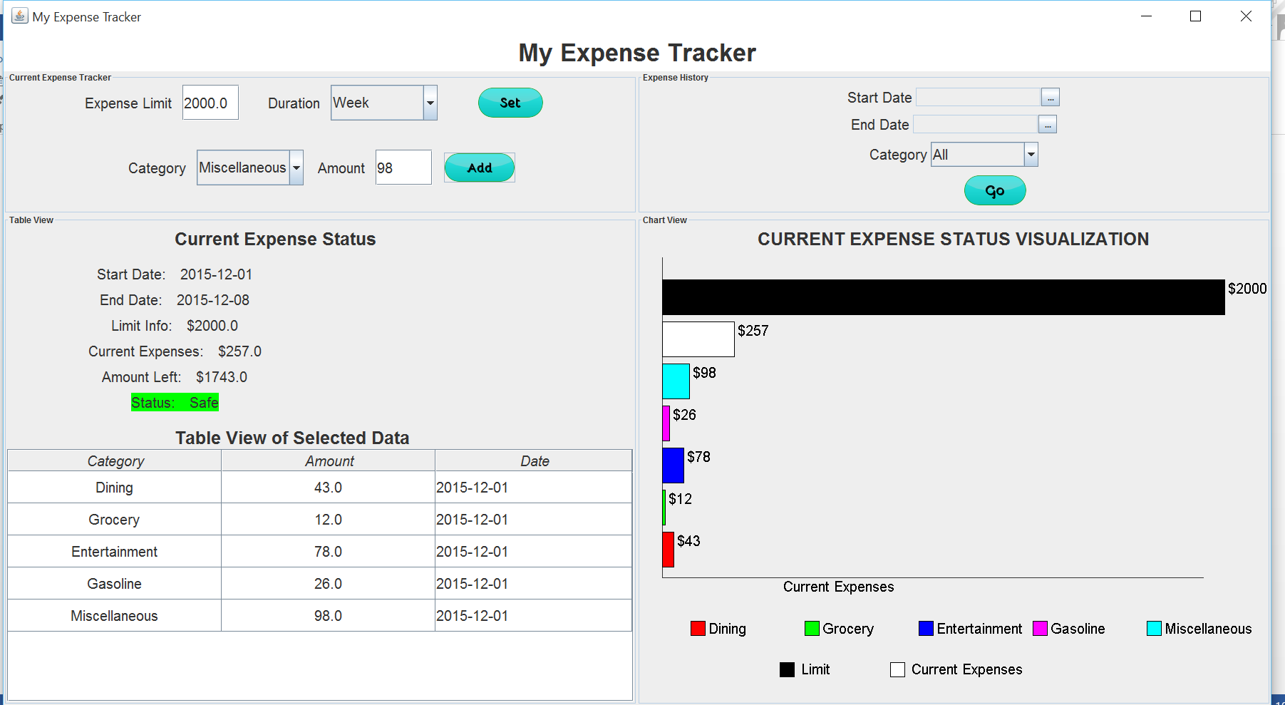
Amount spent under each category is entered.
- As and when the amount is entered, it gets added in the tabel view under that category and today’s date
- Simulateneously the chart view is updated and the “white” bar gives the total expenses and black bar is the set expense limit. The colored bars gives the expenses under each category. The color and the category mapping is provided in the legend.
- “Current Expenses” is the expenses incurred from the start date till today.
- The status is safe until the the Cumulative current expenses is less than the set limit and the “Amount left” is greater than zero.
- When “current Expenses” > “Limit Info”, the following results: ie. The status changes to “exceeded” and is highlighted to red. The Amount by which it is exceeded is given by “Amount Left” which will be a negative value. In the following case, the amount exceeded is by $157
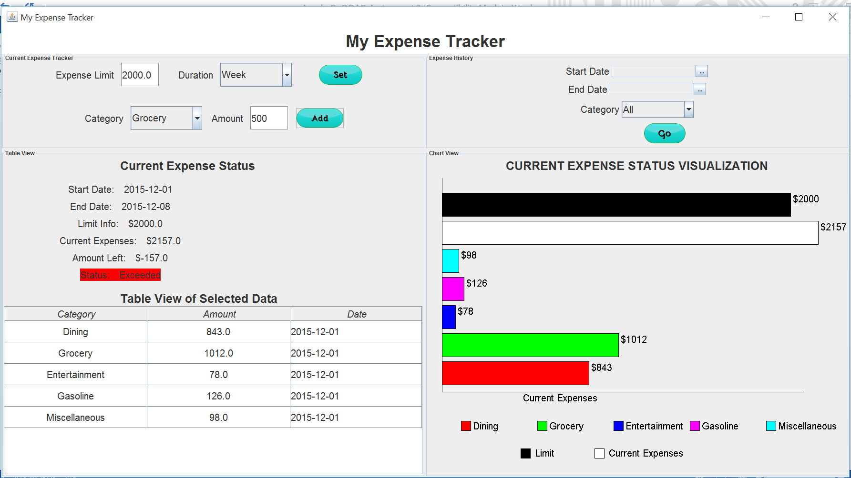

- Select to see money spent under each category and
- Select to see how much is spent (that day) thus far under a chosen (input by the user) category.
4 and 5 requirements are already satisfied by displaying the table view which displays category wise expenses
- Select to see how much is spent (for a period of time, selected by the user) thus far under a chosen category.
In the Expense History panel, the start date and the end date is selected, and by default the category is “All” and click on Go. “Table View of Selected Data” will display all the expenses in each category within the duration selected. Note that there will be no update on the current expense status and the visualization as they render only current details in view.
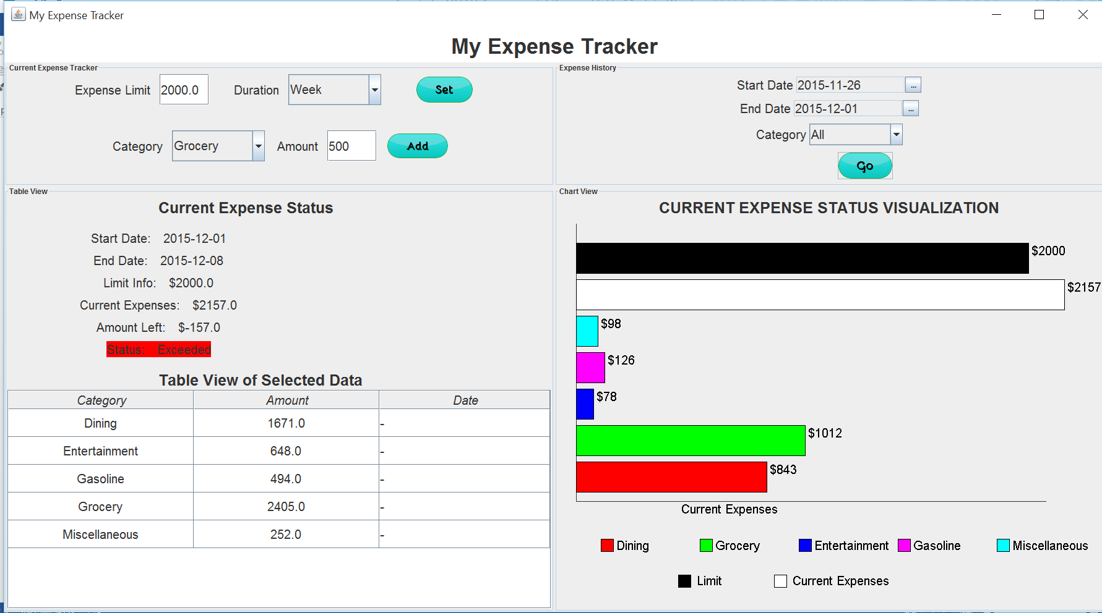
When a particular category is selected(“Dining”) expenses incurred in the selected duration for that category alone is displayed in the table.
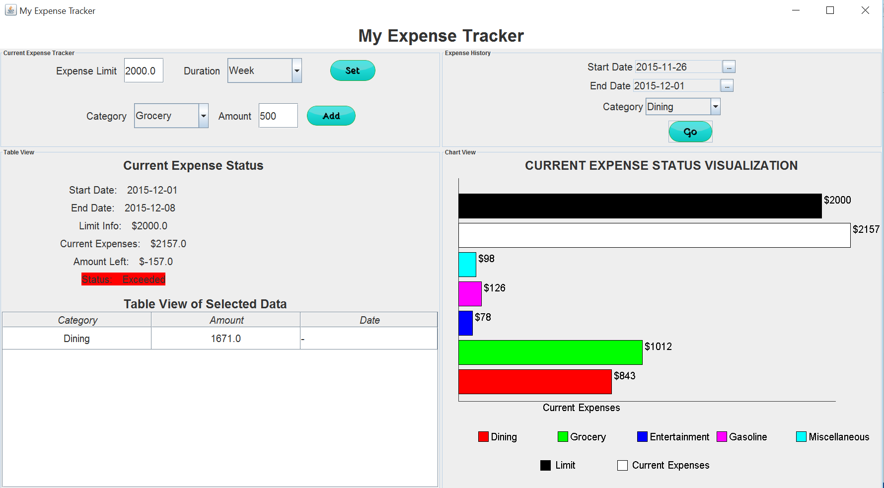
- Select to see a visualization of the expenses (under each category) compared to the expense limit.
This requirement is satisfied by the visualization in the Chart view where the black bar gives the expense limit and the white is the cumulative current expenses. Other colored bars are expense under each category for the set expense limit.

Other Use Cases

When limit is not set and the expenses are added
The Current Expenses will show the cumulative expenses for that day and table will display the category wise expenses. The visualization will show the expense limit to be 0 and the cumulative expense for that day is given by the white bar. The category wise expenses are shown by the colored bars
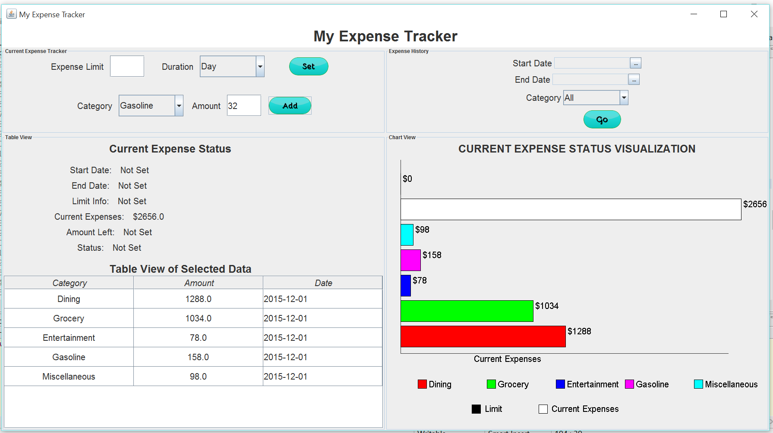

When limit is set for a month and you are on the last day of the month
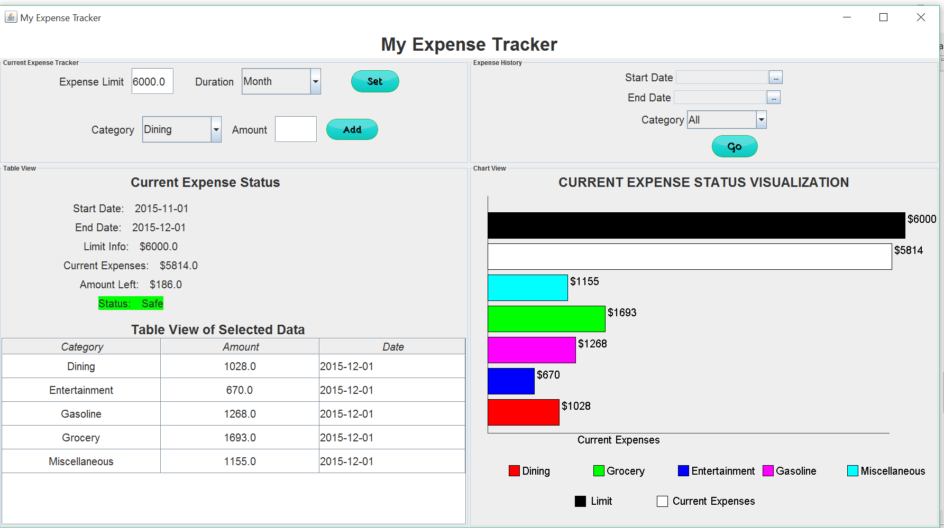
The home screen details all the expenses till the current date that includes all the expenses for the past month and visualization show accordingly. On 2nd of December the limit details will be reset to “Not Set” as the end date of the limit expires and the table will have values of only December 2nd and not the previous ones.

